# ELECRONIC KNOW YOUR CUSTOMER(E-KYC) USING RPA

### **SCOPE OF THE PROJECT**

The project “**Electronic- Know Your Customer** (E-KYC)” is about how to automate the manual process of filling the KYC form. Computer software or a “robot” to capture and interpret existing applications for collecting details of candidates from the Excel sheet, reading the Excel data, generating the template, exporting to pdf.

In this project a webpage is designed separately for filling the KYC form with details like user details and their aadhar, pan, licence number. The same details are filled in KYC form and processed through RPA. The final output is sending a mail to the candidates mentioned in excel sheet.

## PROBLEM DEFINITION

The existing system of KYC needs a manual assessment to approve the candidate personal details which are entered through forms, are liable to mistakes and lot of time consumption and man power.

Our proposed system reads the details from excel sheet and complies the same in the KYC form, so that the issue of typing mistakes and time consumption are reduced.

Generating the KYC for every candidates can be handed over to a RPA solution which can do this activity automatically and without even any manual intervention during the process. The system is planned to be built using UI path studio and triggered using UiPath Robot.

TOOLS USED: UiPath tool

**MODULE SPLIT UP**Module 1 : Collecting Candidates details

Module 2 : PDF Automation

Module 3 : Creating a website to upload the files

Module 4 : E-mail automation

**INPUT:**

The input is an Excel sheet, containing details of candidates, which are collected from the consultancy.

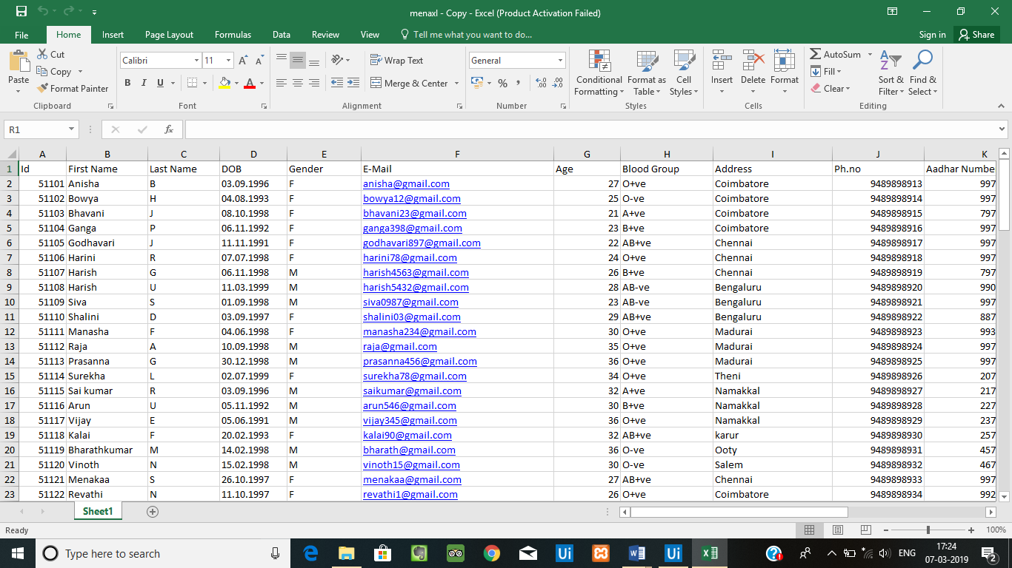

**OUTPUT:**

The final output will be in the form of pdf and this is the template that specifies it.

